CSA Newsletter Week #16:

Fall Harvest Time!
The mornings are cold, afternoons warm and evenings are mild this fall in Alberta. We are keeping busy harvesting the roots out of the garden, swathing & combining grain and filling up the bins for the long winter ahead. We have some young greens that are doing very well in this fall weather that you will be enjoying for the remaining 3 weeks of our CSA (3 including this week). We are planning to fill your fridge with all the Thanksgiving fixings next week, look out!

This week’s bin features:

- Asian Greens Mix
- Steaming Greens Mix
- Potatoes 5lb bag
- Carrots 5lb bag
- Broccoli or Romanesco Broccoli or Cauliflower
- Cabbage
- Leeks
- Onions
- Edible Flowers
- Curly Parsley bunch
- Sage or Lemon Balm

Add-on Shares:
- Pork Chops (2packs) & Chorizo Sausage
- Red Fife Wheat Flour
- Sun berry Jam and Apple Jelly
- 1 dozen farm fresh, free range eggs

Recipe of the Week:
Rustic Cabbage Soup

1 tablespoon extra-virgin olive oil
a big pinch of salt
1/2 pound potatoes, skin on, cut 1/4-inch pieces
4 cloves garlic, chopped
1/2 large yellow onion, thinly sliced
5 cups stock (see head notes)
1 1/2 cups white beans, precooked or canned (drained & rinsed well)
1/2 medium cabbage, cored and sliced into 1/4-inch ribbons
More good-quality extra-virgin olive oil for drizzling
1/2 cup Parmesan cheese, freshly grated

Warm the olive oil in a large thick-bottomed pot over medium-high heat. Stir in the salt and potatoes. Cover and cook until they are a bit tender and starting to brown a bit, about 5 minutes - it's o.k. to uncover to stir a couple times. Stir in the garlic and onion and cook for another minute or two. Add the stock and the beans and bring the pot to a simmer. Stir in the cabbage and cook for a couple more minutes, until the cabbage softens up a bit. Now adjust the seasoning - getting the seasoning right is important or your soup will taste flat and uninteresting. Taste and add more salt if needed, the amount of salt you will need to add will depend on how salty your stock is (varying widely between brands, homemade, etc.)...

Serve drizzled with a bit of olive oil and a generous dusting of cheese.
Serves 4.

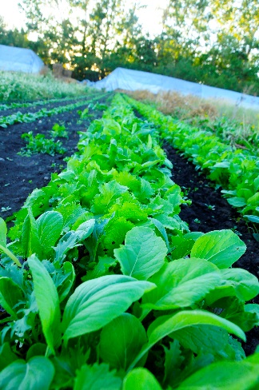
Young Asian Green.

