CSA Newsletter Week #8:

Meet Our Crew!
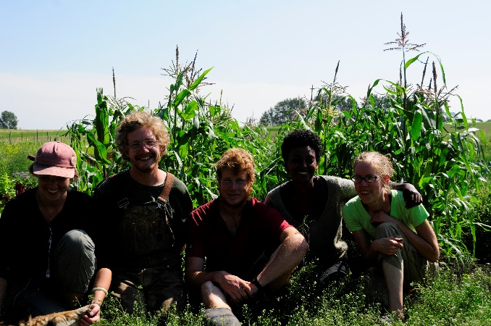
We wanted to introduce you to our 2014 apprentices, the faces behind your weekly produce bins. Without them none of this would be possible and we wanted to show them off to you this week. We will feature them all individually in our coming newsletters to hear why they have chosen to work and learn with us this season. They have all put in so many hours to make this growing season possible and we are really grateful for all they have contributed.
From left to right: Cate Campbel (part time apprectice), Peter Penkala (our crew leader), Tobias Hanbury-Webber (full time apprentice), Bethel Tesfay (full time apprentice), & Meghan Way (full time apprentice).

This week’s bin features:

- Kale & Collards
- Rainbow Chard
- Baby Carrot Bunches
- Baby Beet Bunches
- Broccoli
- Zucchini
- Peas
- Green Cabbage
- Lettuce head with edible flowers & basil
- Fennel
- Curly or Italian Parsley
- Summer Savory
- Green Onion
- Raspberries!

Add-on Shares:
- Italian Sausage & Breakfast Patties
- Red Fife Wheat Flour
- Apricot Jam
- 1 dozen farm fresh, free range eggs

Recipe of the Week:
Easy Coleslaw
5 cups shredded cabbage
2 large carrots, grated
¾ cup mayonnaise
1/3 cup apple cider vinegar
2 tbsp. honey
1 tsp. caraway seeds
¾ tsp. salt or more to taste

- Toss the cabbage and carrots in a large bowl
- Mix the mayonnaise, vinegar, honey & caraway seeds in a small bowl. Pour dressing over cabbage, toss to combine.

