CSA Newsletter Week #9:

We are over half way through our CSA season!
This is exactly half way through the 18 weeks of our CSA. The season is full on and the bounty is beautiful. The bins were on the slim side when we started the shares on June 19, but now they are robust! Please send us your photos and recipes that you are using for your weekly shares and we will share them in our weekly newsletter or on our Facebook page.

This week’s bin features:

- Beans
- Peas
- Carrot Bunches
- Beet Bunches
- Cauliflower
- Broccoli
- Steaming Greens
- Kale
- Lettuce with Edible Flowers & Herbs
- Parsley
- Sage
- Green Cabbage
- Zucchini
- Raspberries!

Add-on Shares:
- Whole Chicken
- Barley Flour
- Zucchini Relish
- 1 dozen farm fresh, free range eggs

Recipe of the Week:
Broccoli with Asian-Style Dressing
Serves 2 – 4
Be careful this can be addictive!
For variety, try adding matchstick-size strips of steamed carrots or daikon.

1medium head broccoli
½ cup rice wine vinegar
3 tbsp. peanut oil
2 tbsp. soy sauce
1 teas grated fresh ginger
½ teas minced garlic
½ teas toasted sesame oil
½ teas hot chili oil (optional)

- Separate the florets from the stalk; break into smaller florets. Cut the stalk into 1-inch lengths and then into matchstick-size strips.
- Place the broccoli in the steamer basket set over 1 ½ inches boiling water and cover. Steam for 5 minutes. Transfer the broccoli to a bowl.
- Combine the remaining ingredients in a small bowl; stir until well combined. Pour the dressing over the broccoli and mix well.

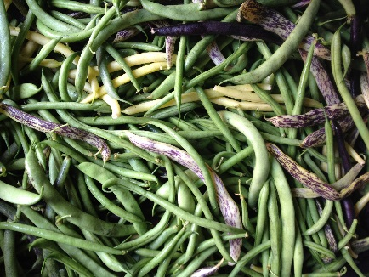
8 varieties of Beans

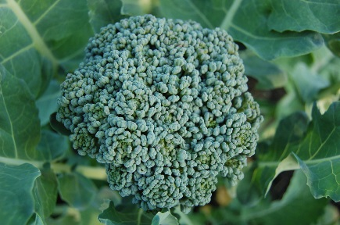
Broccoli

