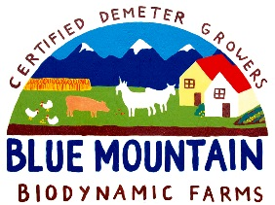 CSA Newsletter Week #15:

What are you doing Saturday September 27th?
We have 2 very fun events booked for this coming Saturday! 1: the 3rd annual cliff bungalow mission picnic as part of Alberta Culture Days 11-7pm & 2: Wildwood Harvest Festival and Farmers Market from 1-4pm. We will have fresh veggies, preserves and freshly milled flour available at both events. Please spread the word and we hope to see you there!

This week’s bin features:

- Yukon Gold Potatoes
- Beets
- Carrot Bunch
- Asian Greens
- Leeks
- Garlic
- Steaming Greens Mix (kale, chard & collards)
- Broccoli
- Cauliflower OR Romanesco Broccoli
- Kohlrabi
- Edible Flowers with Dill
- Sage OR Thyme
- Curly OR Italian Parsley

Add-on Shares:
- Bratwurst Sausage & Ground Pork
- Barley Flour
- Pear & Vanilla Bean Jam
- 1 dozen farm fresh, free range eggs

Recipe of the Week:
Simple Sautéed Kohlrabi

Quick, simple, and satisfying, this recipe celebrates the greatness of kohlrabi. Serve as is, as a salad on a bed of steaming/braising mix or as a side to grilled or roasted meats.

2 medium Kohlrabi bulbs, grated
1 teaspoon Salt
¼ cup Butter or light oil
1 medium Onion, diced (about ½ cup)
1 clove Garlic, minced or pressed
2 tablespoons chopped fresh Thyme, Chives or Sage

- Mix the Kohlrabi and Salt in a colander and let it stand for 30 minutes to drain.
- Melt the butter in a medium skillet over medium heat. Add the onion and sauté until translucent, about 3 minutes. Add the Garlic and sauté for 1 minute more.
- Stir in the kohlrabi. Reduce the heat to low, cover, and cook for 10 minutes.
- Increase the heat to medium, uncover the skillet, and cook for 2 minutes. Remove from heat and stir in the fresh herbs. Let stand for a couple of minutes to let the flavors develop.

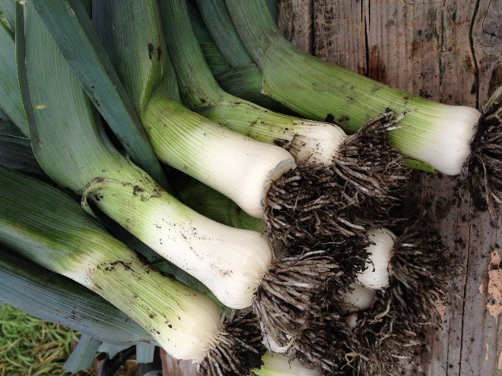
Leeks waiting to get cleaned up before going in your shares.

