CSA Newsletter Week #17:

Giving Thanks for the Harvest:
We have 3 Moose living in one of our pastures, we think they come back every year. They have helped us harvest the rest of our broccoli, so you will not find any in your bins this week. They are beautiful majestic creatures, and we are pleased they have enjoyed the broccoli. We are happy to celebrate this thanksgiving by filling your bins up with all the wonderful fall vegetables and herbs for your harvest meal.

This week’s bin features:

- Potatoes 5 lbs.
- Carrots 1.5 lbs.
- Beets 1.5 lbs.
- Sunchokes 1.5 lbs.
- Steaming Greens
- Cabbage
- Leeks 2-4
- Onions (small)

- Rutabaga or Kohlrabi
- Edible Flowers
- Poultry Mix 2oz. bag: Parsley, Sage & Thyme

Add-on Shares:
- (Thanksgiving) Smoked Ham
- Rose Hip Jelly
- Rye Flour
- 1 dozen farm fresh, free range eggs

Recipe of the Week:
Beet Root Brownies
This recipe was provided by our Shareholder
Amber Storey
What you need:
500 grams whole raw beets (3-4 medium sized)
1/2 cup coconut oil
200 gram bar of plain chocolate (or approx. 1 cup chocolate chips)
1-2 tsp vanilla extract
1 1/4 cups sugar
3 eggs
3/4 cup and 1 tbsp. flour
1/4 cup and 2 tsp cocoa powder
What you do:
1. Clean the beets, cut them into chunks and boil. No need to peel them.
2. Butter a 8" X 11" cake pan. Preheat oven to 350.
3. Drain the beets and puree with chocolate, oil and vanilla. Use a food processor, blender or immersion blender for this.
4. Whisk together sugar and eggs until foamy. Fold in the beet mixture, trying to keep as much air as possible in the mix.
5. Add the flour and cocoa powder. Mix until smooth.
6. Bake approx. 25 minutes, until it's risen all over "with just the merest quiver under the center of the crust when you shake the pan"
7. Cool and enjoy.
For bonus points, if you feel the need for icing... keep the water the beets are cooked in and use it to make a naturally coloured pink icing!!

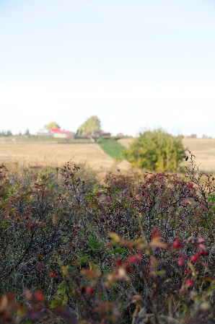
Picking Rose Hips in the pasture
And looking up at the farm.

