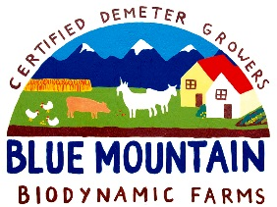 CSA Newsletter Week #18:

And that’s a Wrap, the last bin of our 2014 CSA:
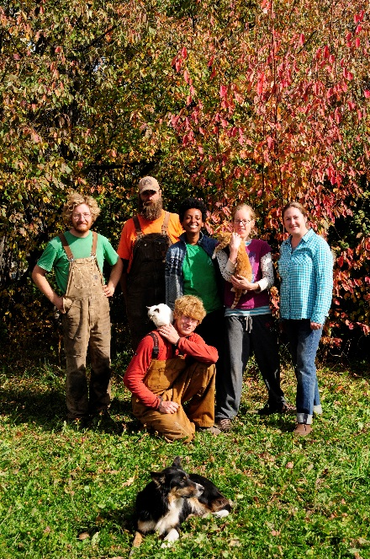
We want to thank each and every one of your for participating in our CSA. We hope you have enjoyed it as much as we have. We had an amazing farm crew this year that helped us make this all possible and we want to thank them for all the work they put into this project and for helping us with all of our other weekly orders.
We will be sending all of you an online survey in the next week, we are looking for feedback to help us assess what we did right and where we can improve for next year. Please take the time to fill it out. We’ve also attached a graph that outlines the weekly value of our 18 week CSA and gives a weekly average.

This week’s bin features:

- Salad Greens Mix: Lettuce, Arugula, Mache, Asian Greens & Spinach
- Early Ohio Potatoes 4.5 lbs.
- Cabbage
- Kohlrabi
- Edible Flowers with Dill & Nasturtium leaves
- 1 Sugar Pie Pumpkin (from Fisher Farms)
- 1 jar Sauerkraut (made by our shareholders Stef Holt & Tyler Doucette, with Blue Mountain Cabbage)

Add-on Shares:
- Whole Chicken
- Raspberry Jam
- Barley Flour
- 1 dozen farm fresh, free range eggs

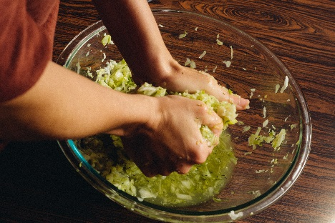
Photos taken by Tyler Doucette

