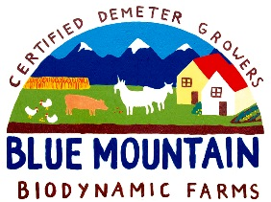 CSA Newsletter Week #7:

Hot-dang!
What a hot week we’ve had, and the temperature is supposed to stay high for the remainder of the week! We are taking a bit of a break from all the greens to let some of the plants recover and bring on some new growth. We’ve had a few really busy picking weeks supplying retail stores, home delivery services a few restaurants and of course, our priority, You! We have a few new vegetables for you this week; cabbage, beans, beets & potatoes! Next week we are hoping to impress you with fresh Raspberries!

This week’s bin features:

- Big Green Wonder Lettuce Mix with edible flowers & herbs
- Steaming Greens Mix
- A head of Lettuce
- Bunche of Beets
- Bunch of Baby Carrots
- Endive
- Green Cabbage
- New Potatoes
- Peas
- Beans
- Chives (for Amy & Will’s little girl who cried when there were no chives last week, this is for her!)
- Parsley
- Kale Bunch

Add-on Shares:
- Bacon & a surprise. (We are counting on getting our order back from the butchers today!)
- Barley Flakes
- Blueberry Raspberry Jam
- 1 dozen Farm fresh, free range eggs

Recipe of the Week:
Green Bean Salad with Walnuts and Shaved Parmesan in a Lemon Dressing
¼ cup coarsely chopped walnuts
1 pound beans
1 teaspoon fresh ground pepper
1 ½ tablespoon fresh squeezed lemon juice (about ½ lemon)
3 tablespoons extra virgin olive oil
4 ounces Parmesan cheese, thinly shaved (about ½ cup)
Serves 4-6

- Toast the walnuts in a dry, heavy skillet over high heat until they start to brown in spots and become fragrant.
- Bring a large pot of water to a boil. Add the beans and salt; cook until tender but still firm, 3-5 minutes.
- Transfer the beans to a colander in the sink and run cold water over them. Trim the beans if necessary.
- Toss the beans and walnuts in a large bowl and season with salt & pepper to taste.
- In a small bowl, whisk the lemon juice and olive oil until well combined. Pour the mixture over the beans and toss until well coated. Transfer the salad to a serving platter or individual plates. Gently scatter the Parmesan shavings on top.

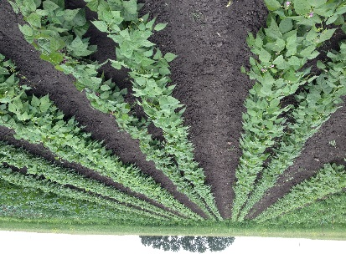
Bean plants

